Paul – Behavior Example

Raw Data Collected by Teacher during Reading and Math Blocks

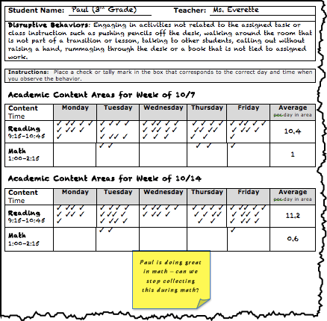

Raw Data from Reading and Math Blocks Graphed

